Groove Subtraction

Definition
# Source: AI Source: Provided by: [Data Path: Persons Table -> ID Column: 1, Name_En Column: Motasem Essam] -> From: [ChatGPT] on [7/25/2026]
Groove Subtraction is a method of forming a modified solid by removing an elongated portion of material from its surface to create a narrow or extended channel, trench, or recessed track.
A groove generally follows a particular direction along the solid and has a defined cross-sectional shape. It may extend along the entire length of a solid or cover only a portion of its surface.
Unlike a notch, which is typically an open cut-out at an edge or corner, a groove is usually formed along a surface and may be completely surrounded by the original surface.

Simple Definition
# Source: AI Source: Provided by: [Data Path: Persons Table -> ID Column: 1, Name_En Column: Motasem Essam] -> From: [ChatGPT] on [7/25/2026]
Groove subtraction means removing an elongated strip of material from a solid's surface to create a recessed channel or track.

Geometric Representation
# Source: AI Source: Provided by: [Data Path: Persons Table -> ID Column: 1, Name_En Column: Motasem Essam] -> From: [ChatGPT] on [7/25/2026]
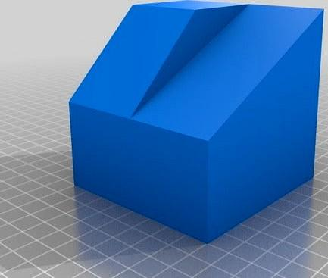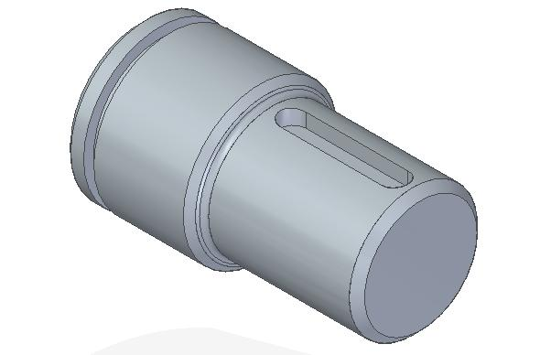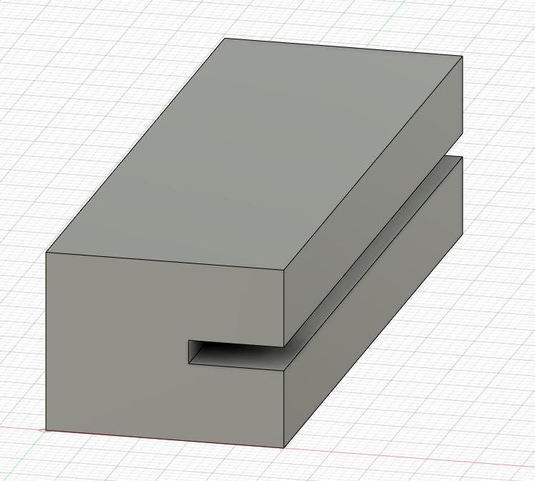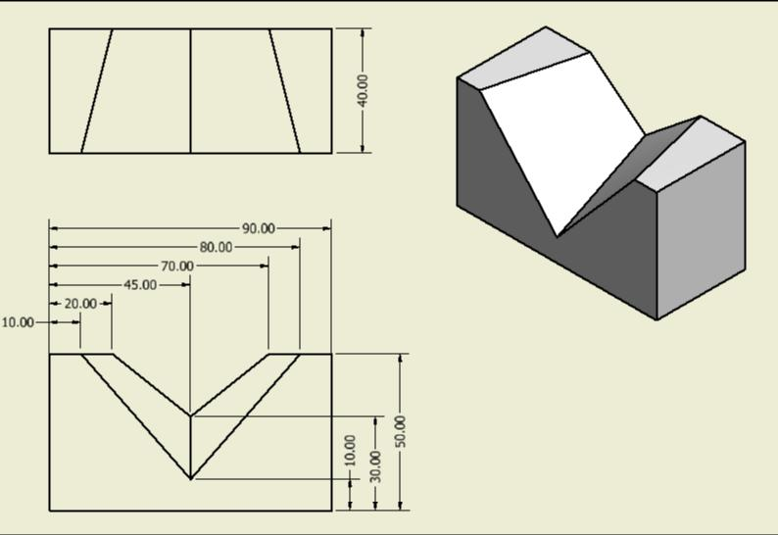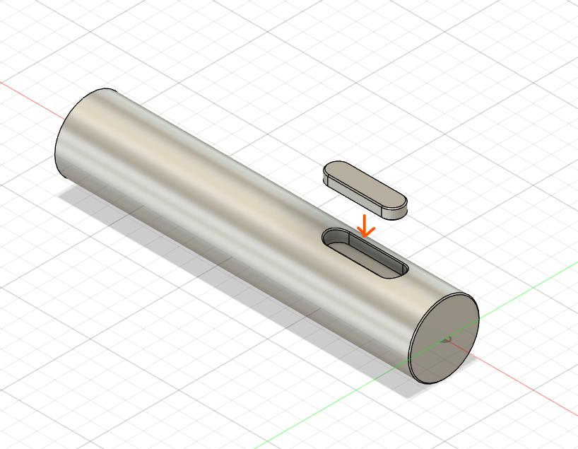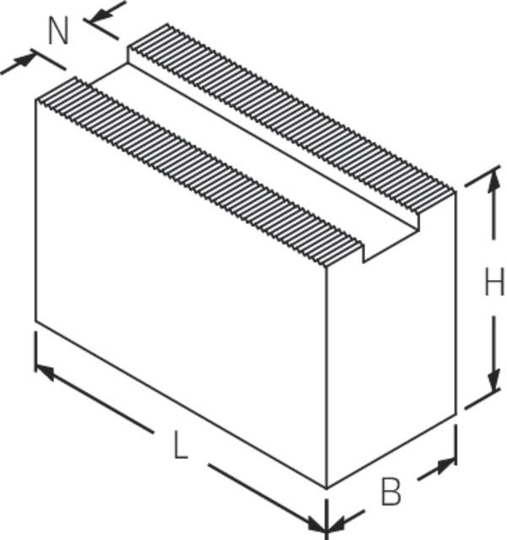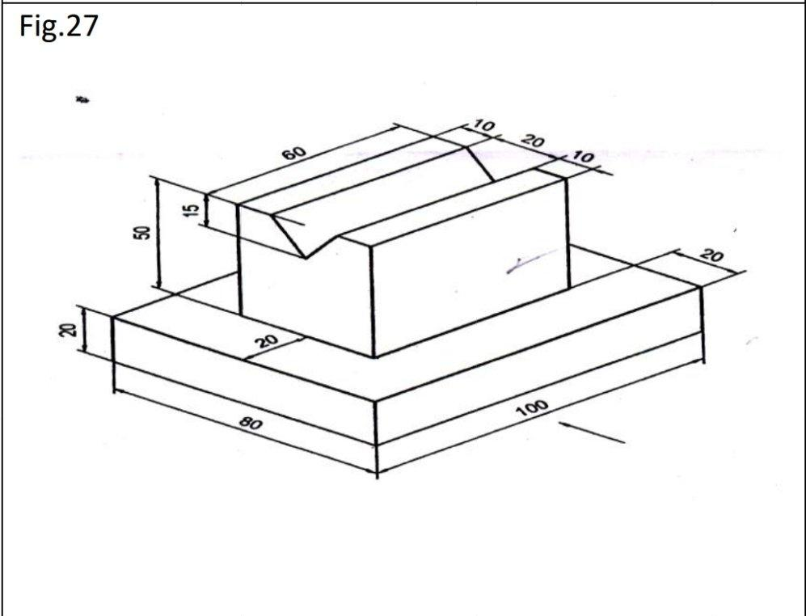
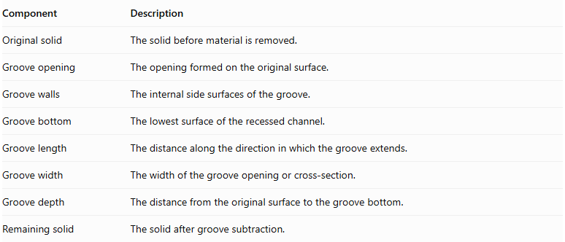
Component | Description
Original solid | The solid before material is removed.
Groove opening | The opening formed on the original surface.
Groove walls | The internal side surfaces of the groove.
Groove bottom | The lowest surface of the recessed channel.
Groove length | The distance along the direction in which the groove extends.
Groove width | The width of the groove opening or cross-section.
Groove depth | The distance from the original surface to the groove bottom.
Remaining solid | The solid after groove subtraction.

Main Classification
# Source: AI Source: Provided by: [Data Path: Persons Table -> ID Column: 1, Name_En Column: Motasem Essam] -> From: [ChatGPT] on [7/25/2026]
Groove subtraction can be classified according to the cross-sectional shape of the removed region.

Rectangular Groove Subtraction
# Source: AI Source: Provided by: [Data Path: Persons Table -> ID Column: 1, Name_En Column: Motasem Essam] -> From: [ChatGPT] on [7/25/2026]
Material is removed to create a groove with a rectangular cross-section.
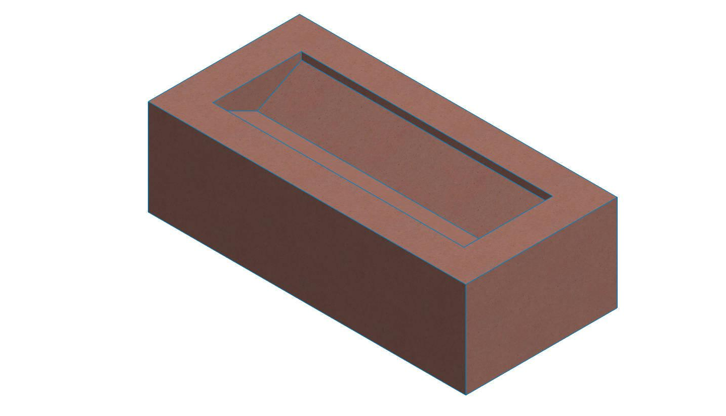
- Cross-section: Rectangular.
- Walls: Two parallel vertical walls.
- Bottom: Flat and rectangular.
- Example: A rectangular channel cut along the top of a block.

Square Groove Subtraction
# Source: AI Source: Provided by: [Data Path: Persons Table -> ID Column: 1, Name_En Column: Motasem Essam] -> From: [ChatGPT] on [7/25/2026]
Material is removed to create a groove with a square cross-section.
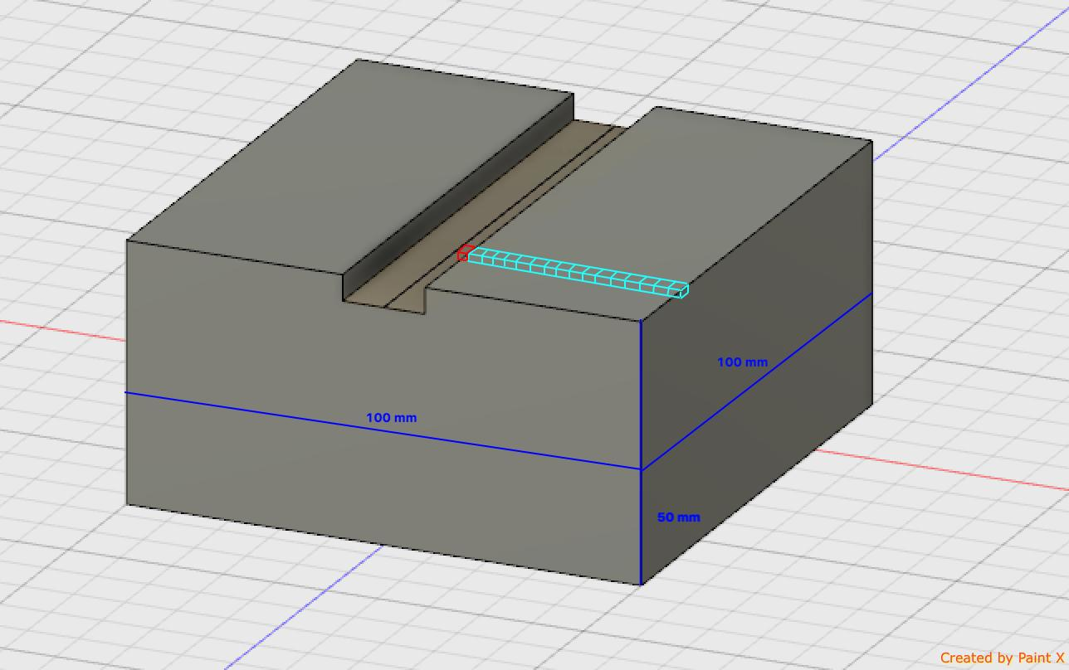
- Cross-section: Square.
- Walls: Two parallel side walls.
- Bottom: Flat.
- Example: A square channel along a rectangular prism.

V-Shaped Groove Subtraction
# Source: AI Source: Provided by: [Data Path: Persons Table -> ID Column: 1, Name_En Column: Motasem Essam] -> From: [ChatGPT] on [7/25/2026]
Material is removed to create a V-shaped channel.
- Cross-section: V-shaped.
- Walls: Two inclined planar surfaces.
- Bottom: Usually a line or narrow region.
- Example: A V-shaped channel in a solid block.

U-Shaped Groove Subtraction
# Source: AI Source: Provided by: [Data Path: Persons Table -> ID Column: 1, Name_En Column: Motasem Essam] -> From: [ChatGPT] on [7/25/2026]
Material is removed to create a U-shaped channel.
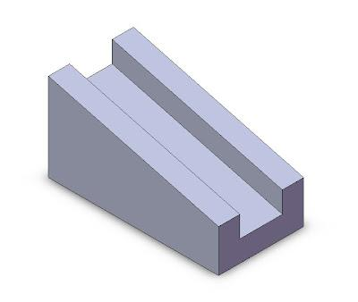
- Cross-section: U-shaped.
- Walls: Two side walls connected by a curved bottom.
- Bottom: Curved.
- Example: A rounded channel along a solid surface.

Semicircular Groove Subtraction
# Source: AI Source: Provided by: [Data Path: Persons Table -> ID Column: 1, Name_En Column: Motasem Essam] -> From: [ChatGPT] on [7/25/2026]
Material is removed to create a groove with a semicircular cross-section.
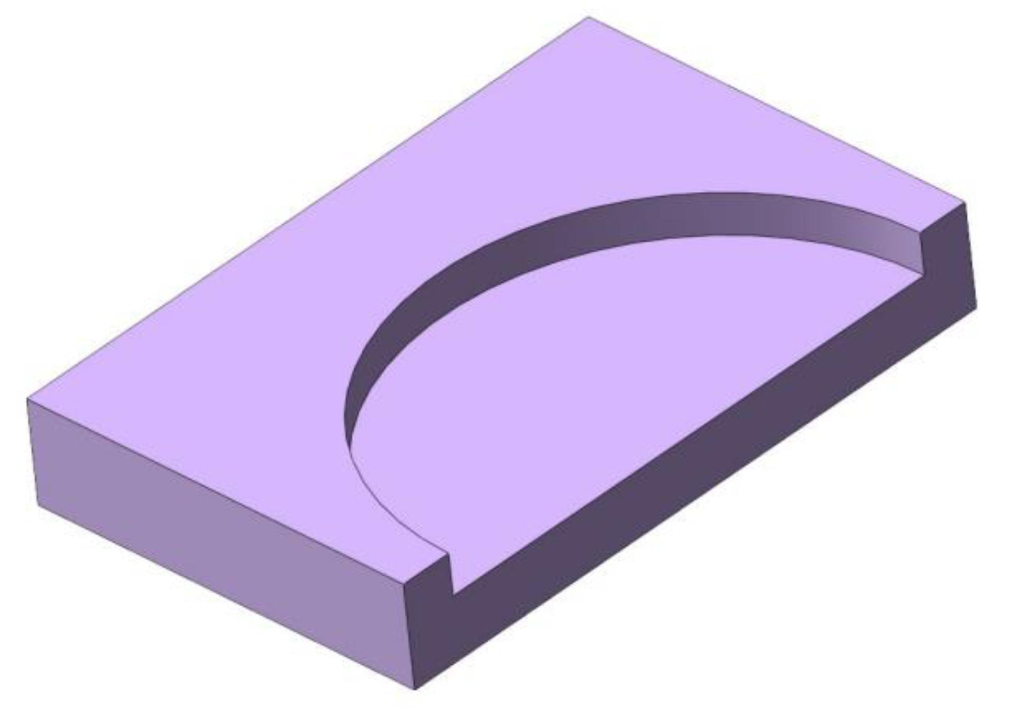
- Cross-section: Semicircular.
- Walls and bottom: Form a continuous curved surface.
- Example: A semicircular channel cut into a block.

Trapezoidal Groove Subtraction
# Source: AI Source: Provided by: [Data Path: Persons Table -> ID Column: 1, Name_En Column: Motasem Essam] -> From: [ChatGPT] on [7/25/2026]
Material is removed to create a groove with a trapezoidal cross-section.
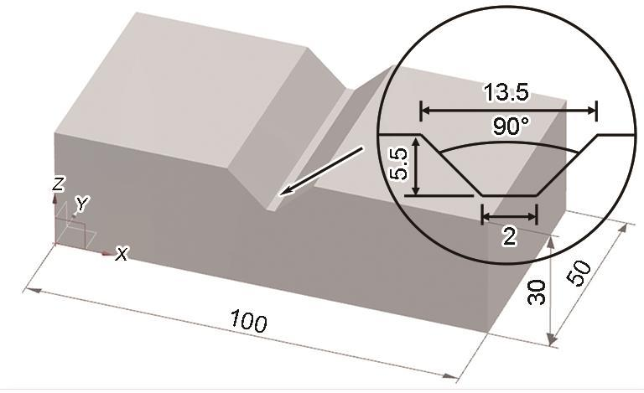
- Cross-section: Trapezoidal.
- Walls: Usually inclined.
- Bottom: Flat.
- Example: A tapered channel with a wider opening than its bottom.

Triangular Groove Subtraction
# Source: AI Source: Provided by: [Data Path: Persons Table -> ID Column: 1, Name_En Column: Motasem Essam] -> From: [ChatGPT] on [7/25/2026]
Material is removed to create a groove with a triangular cross-section.
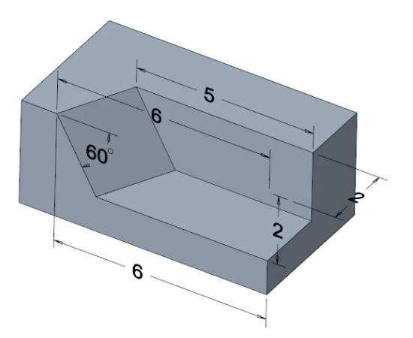
- Cross-section: Triangular.
- Walls: Usually two inclined sides.
- Bottom: A pointed or narrow region.
- Example: A triangular channel along a prism.

Polygonal Groove Subtraction
# Source: AI Source: Provided by: [Data Path: Persons Table -> ID Column: 1, Name_En Column: Motasem Essam] -> From: [ChatGPT] on [7/25/2026]
Material is removed to create a groove with a polygonal cross-section.
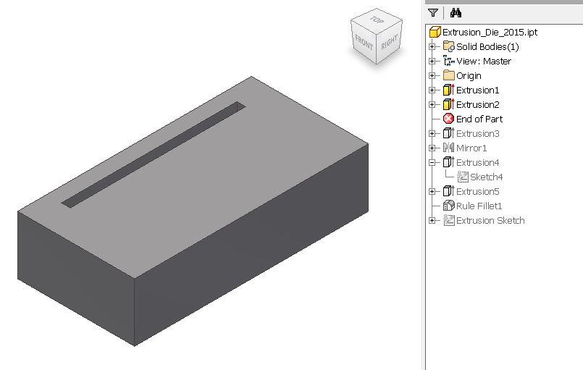
- Cross-section: Polygonal.
- Walls: Multiple flat surfaces.
- Bottom: Depends on the polygonal profile.
- Example: A hexagonal or pentagonal channel.

Irregular Groove Subtraction
# Source: AI Source: Provided by: [Data Path: Persons Table -> ID Column: 1, Name_En Column: Motasem Essam] -> From: [ChatGPT] on [7/25/2026]
Material is removed to create a groove with an irregular cross-section.
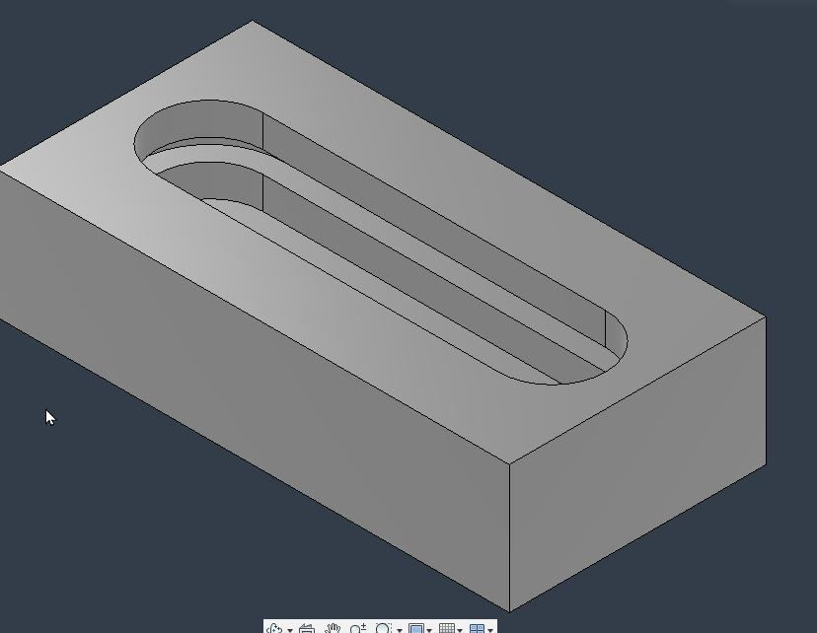
- Cross-section: Irregular.
- Walls: May be flat, curved, or mixed.
- Bottom: Irregular.
- Example: An irregular channel carved into a solid.

Classification by Direction and Path
# Source: AI Source: Provided by: [Data Path: Persons Table -> ID Column: 1, Name_En Column: Motasem Essam] -> From: [ChatGPT] on [7/25/2026]
Grooves can be classified according to the direction or path they follow across a solid's surface.

Longitudinal Groove
# Source: AI Source: Provided by: [Data Path: Persons Table -> ID Column: 1, Name_En Column: Motasem Essam] -> From: [ChatGPT] on [7/25/2026]
A groove extends along the length of a solid.
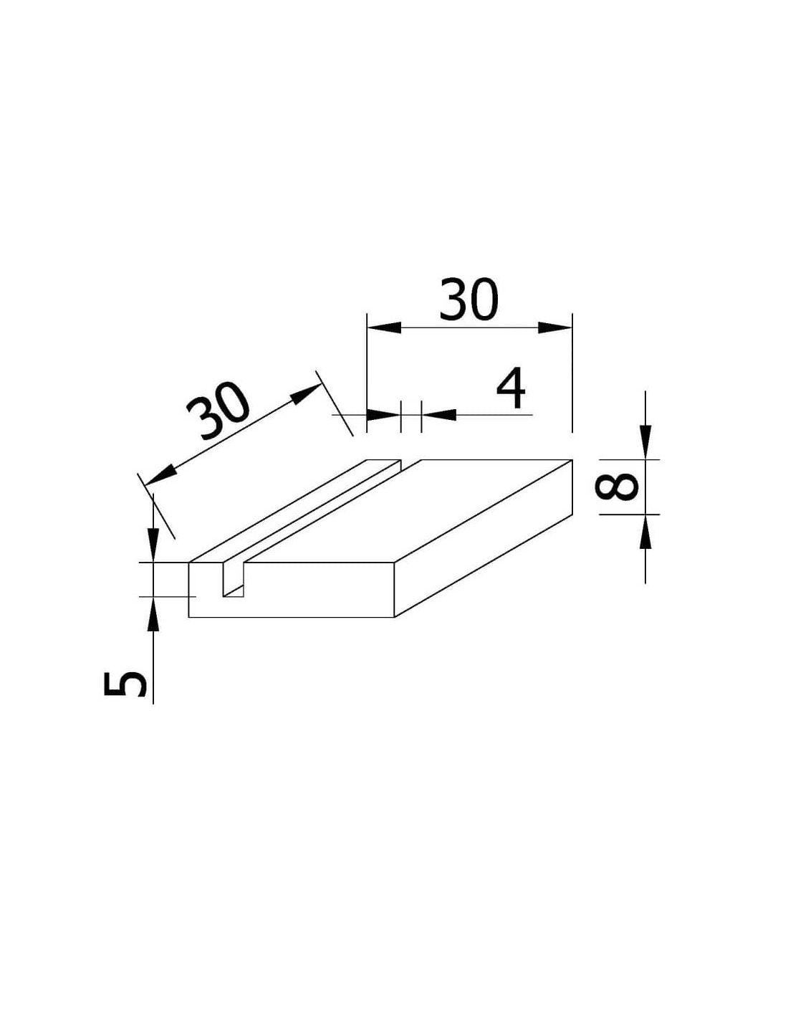

Transverse Groove
# Source: AI Source: Provided by: [Data Path: Persons Table -> ID Column: 1, Name_En Column: Motasem Essam] -> From: [ChatGPT] on [7/25/2026]
A groove extends across the width of a solid.
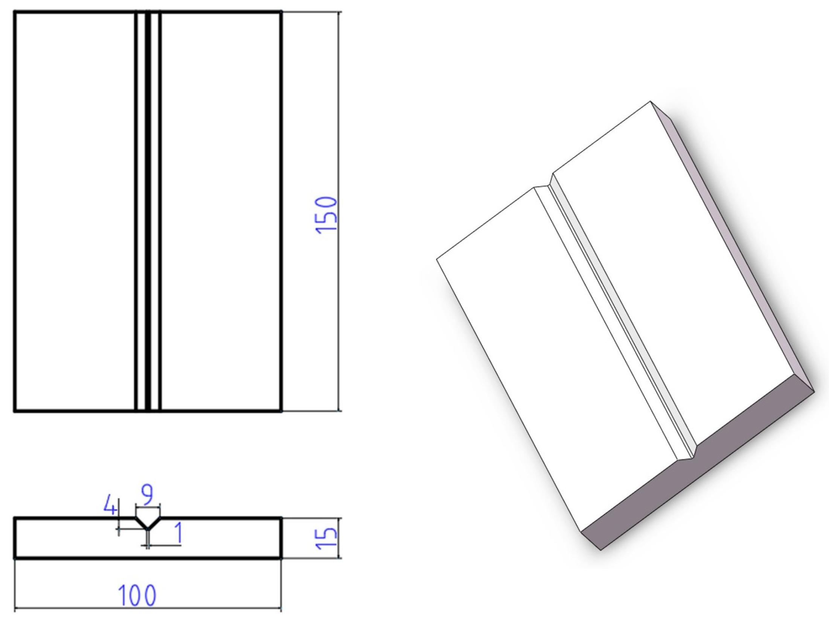

Vertical Groove
# Source: AI Source: Provided by: [Data Path: Persons Table -> ID Column: 1, Name_En Column: Motasem Essam] -> From: [ChatGPT] on [7/25/2026]
A groove extends vertically along a side surface.
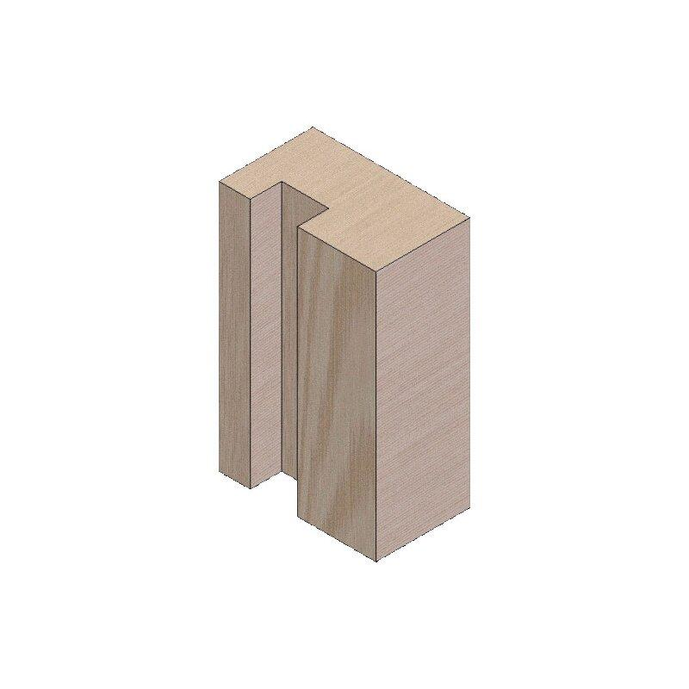

Inclined Groove
# Source: AI Source: Provided by: [Data Path: Persons Table -> ID Column: 1, Name_En Column: Motasem Essam] -> From: [ChatGPT] on [7/25/2026]
A groove follows an inclined direction across a surface.
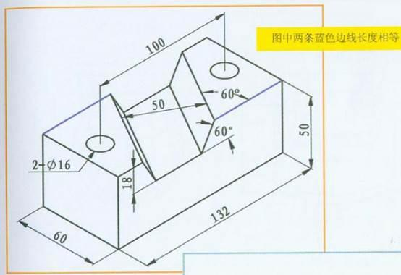

Curved Groove
# Source: AI Source: Provided by: [Data Path: Persons Table -> ID Column: 1, Name_En Column: Motasem Essam] -> From: [ChatGPT] on [7/25/2026]
A groove follows a curved path.
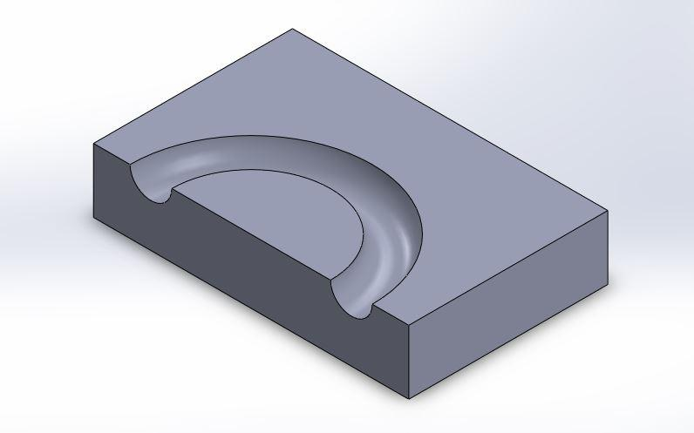

Circular Groove
# Source: AI Source: Provided by: [Data Path: Persons Table -> ID Column: 1, Name_En Column: Motasem Essam] -> From: [ChatGPT] on [7/25/2026]
A groove follows a circular path, often around a common center.
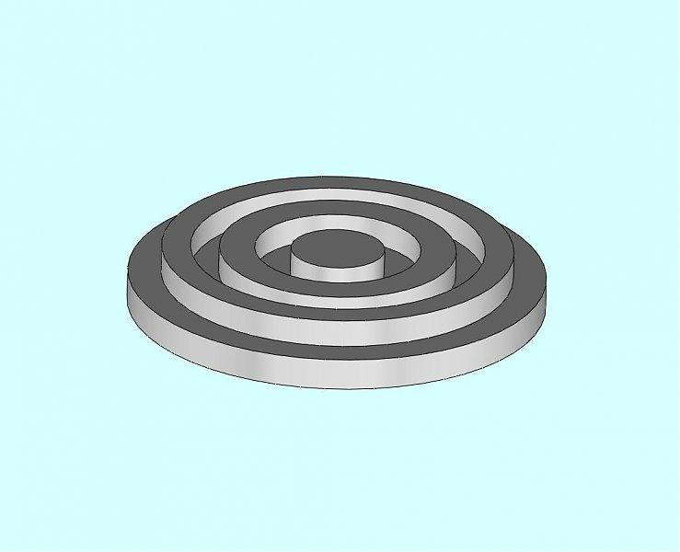

Helical Groove
# Source: AI Source: Provided by: [Data Path: Persons Table -> ID Column: 1, Name_En Column: Motasem Essam] -> From: [ChatGPT] on [7/25/2026]
A groove follows a spiral or helical path around a cylindrical surface.
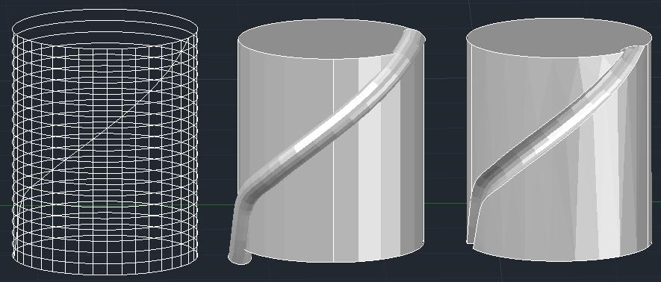

Wavy Groove
# Source: AI Source: Provided by: [Data Path: Persons Table -> ID Column: 1, Name_En Column: Motasem Essam] -> From: [ChatGPT] on [7/25/2026]
A groove follows a repeated wave-like path.
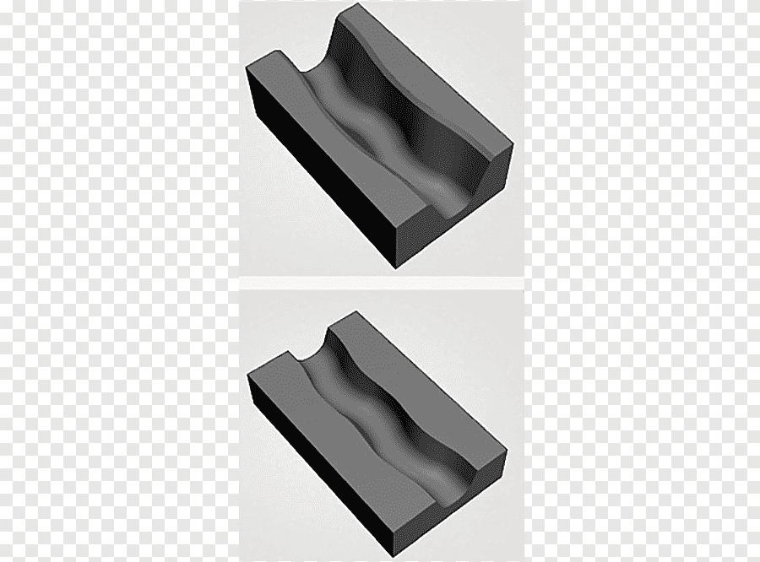

Classification by Groove Depth
# Source: AI Source: Provided by: [Data Path: Persons Table -> ID Column: 1, Name_En Column: Motasem Essam] -> From: [ChatGPT] on [7/25/2026]
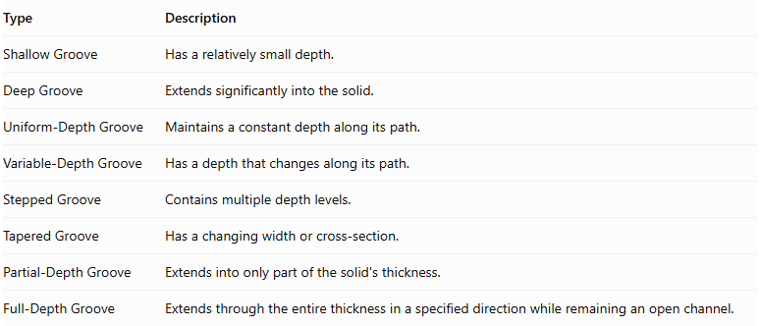
Type | Description
Shallow Groove | Has a relatively small depth.
Deep Groove | Extends significantly into the solid.
Uniform-Depth Groove | Maintains a constant depth along its path.
Variable-Depth Groove | Has a depth that changes along its path.
Stepped Groove | Contains multiple depth levels.
Tapered Groove | Has a changing width or cross-section.
Partial-Depth Groove | Extends into only part of the solid's thickness.
Full-Depth Groove | Extends through the entire thickness in a specified direction while remaining an open channel.
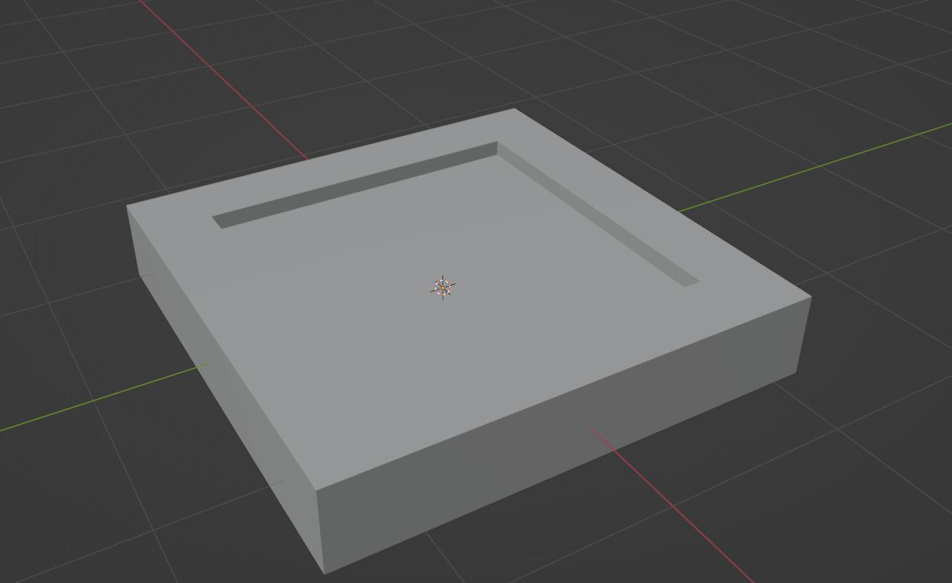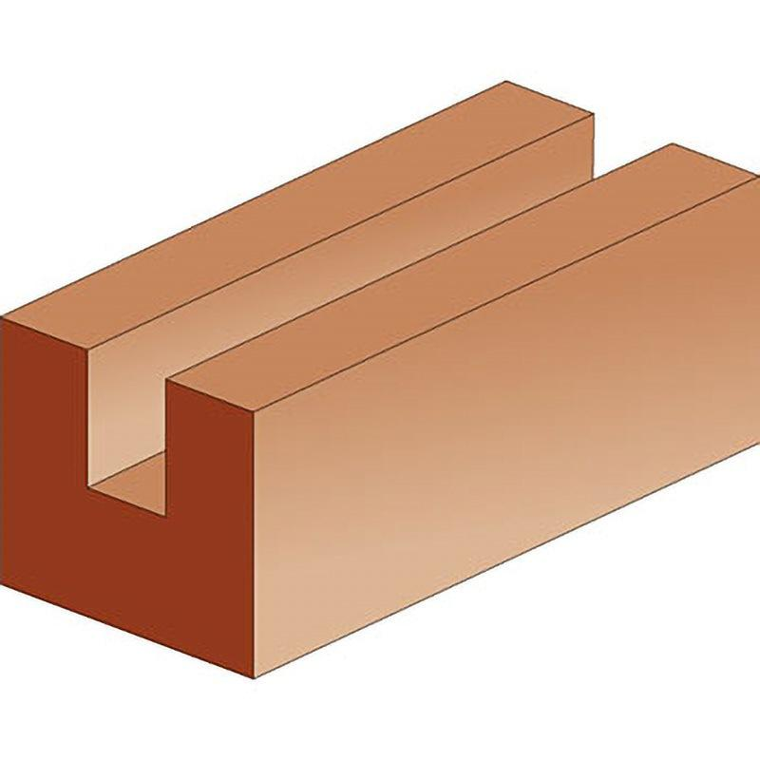

Classification by Number and Arrangement
# Source: AI Source: Provided by: [Data Path: Persons Table -> ID Column: 1, Name_En Column: Motasem Essam] -> From: [ChatGPT] on [7/25/2026]
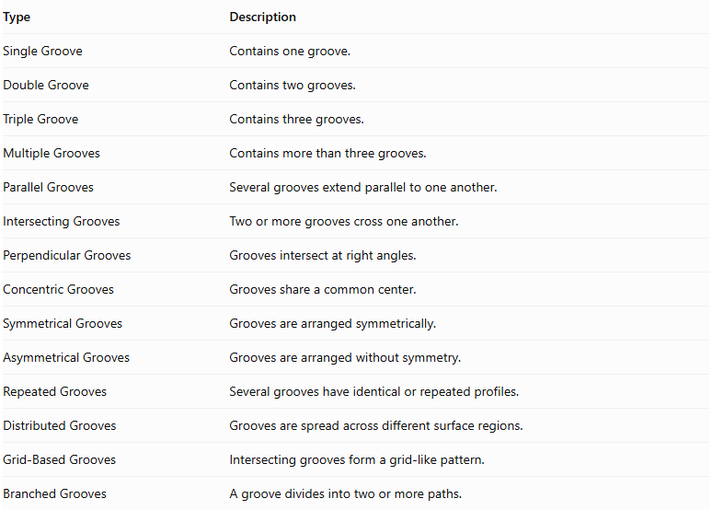
Type | Description
Single Groove | Contains one groove.
Double Groove | Contains two grooves.
Triple Groove | Contains three grooves.
Multiple Grooves | Contains more than three grooves.
Parallel Grooves | Several grooves extend parallel to one another.
Intersecting Grooves | Two or more grooves cross one another.
Perpendicular Grooves | Grooves intersect at right angles.
Concentric Grooves | Grooves share a common center.
Symmetrical Grooves | Grooves are arranged symmetrically.
Asymmetrical Grooves | Grooves are arranged without symmetry.
Repeated Grooves | Several grooves have identical or repeated profiles.
Distributed Grooves | Grooves are spread across different surface regions.
Grid-Based Grooves | Intersecting grooves form a grid-like pattern.
Branched Grooves | A groove divides into two or more paths.
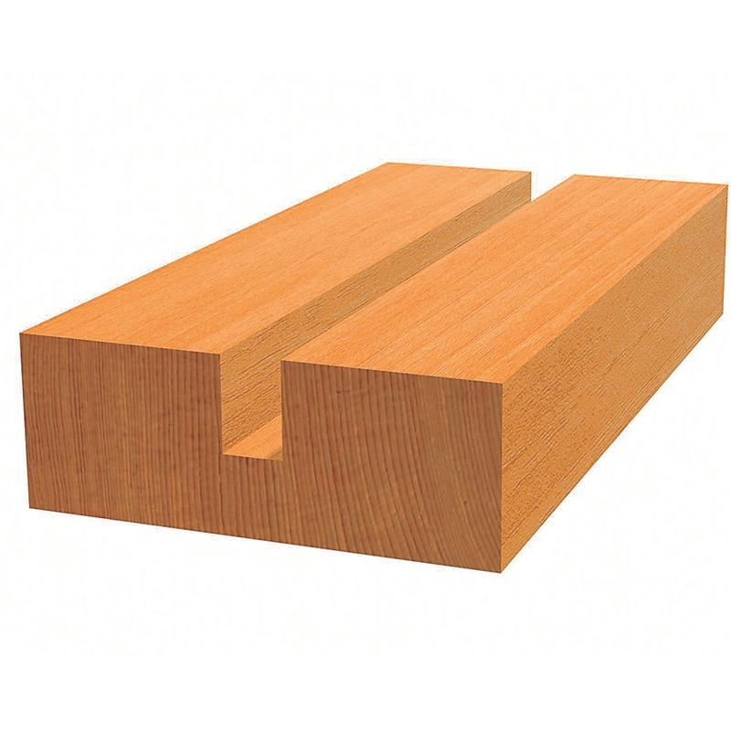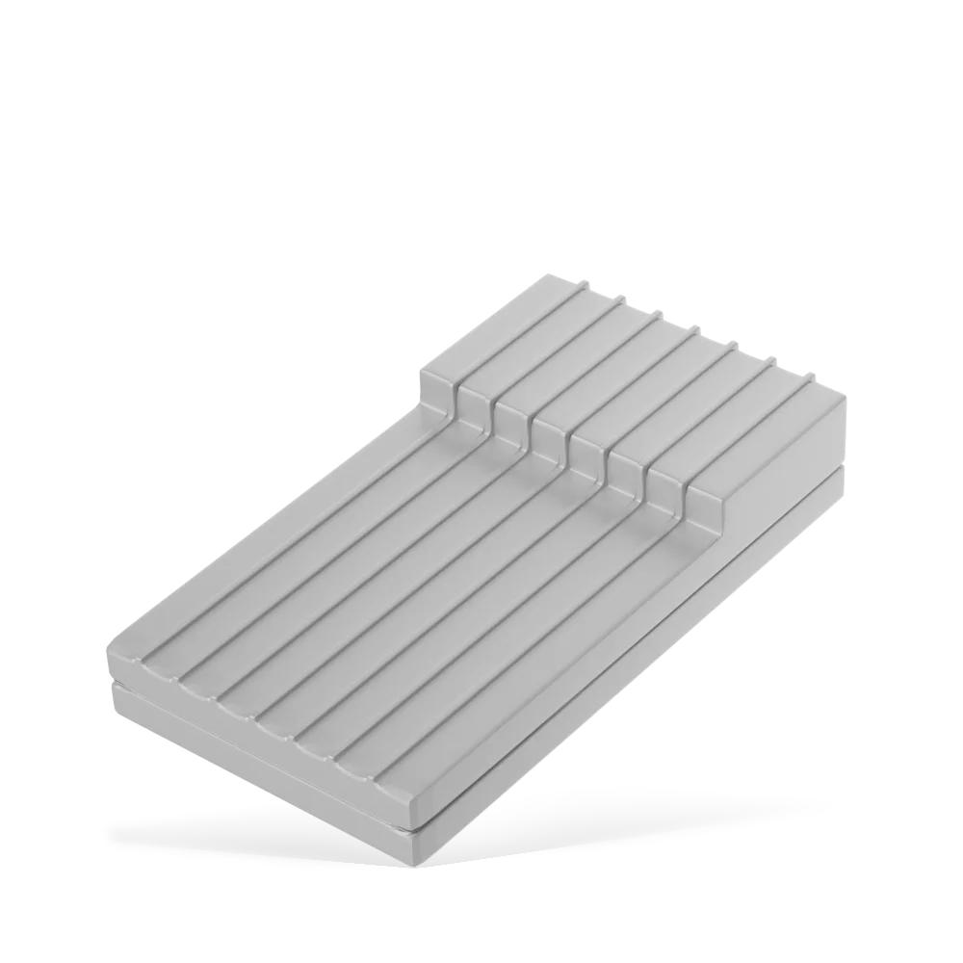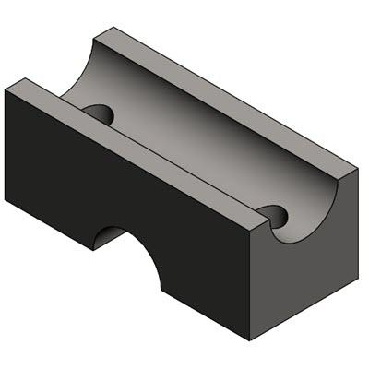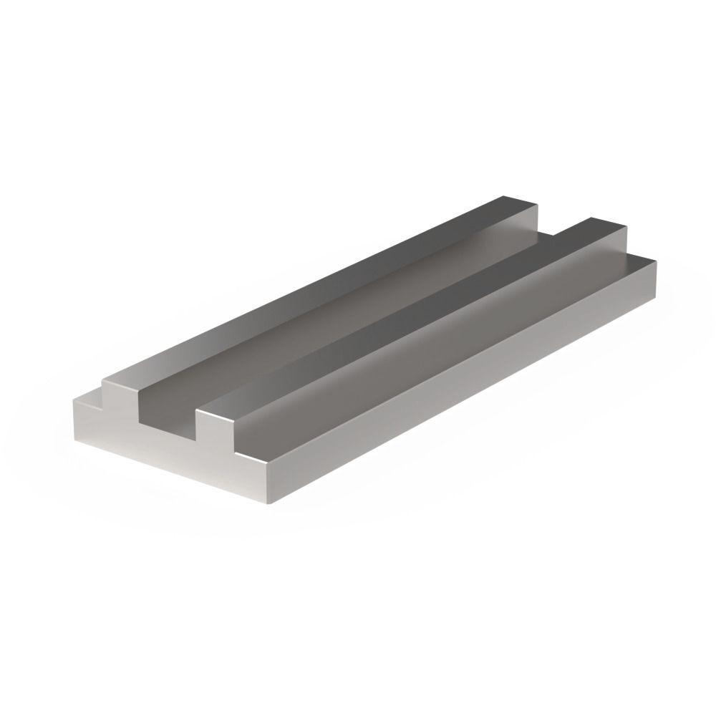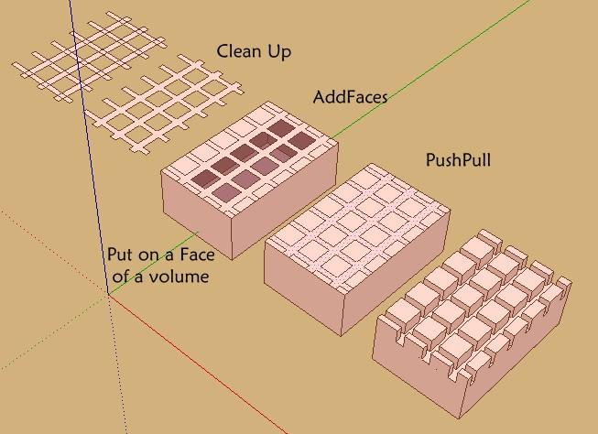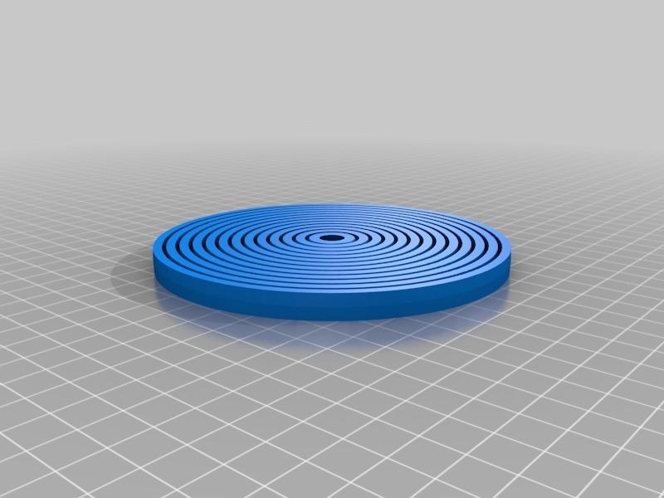

Classification by Surface Location
# Source: AI Source: Provided by: [Data Path: Persons Table -> ID Column: 1, Name_En Column: Motasem Essam] -> From: [ChatGPT] on [7/25/2026]
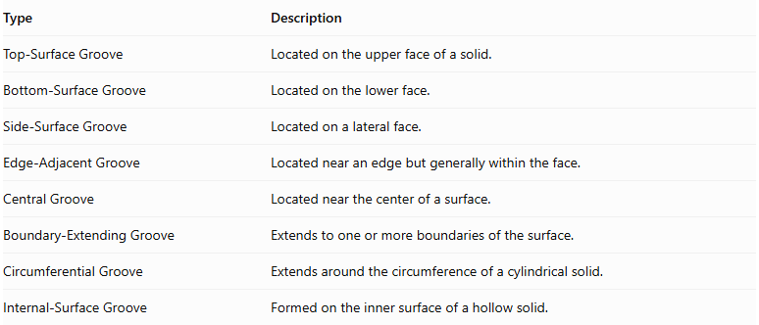
Type | Description
Top-Surface Groove | Located on the upper face of a solid.
Bottom-Surface Groove | Located on the lower face.
Side-Surface Groove | Located on a lateral face.
Edge-Adjacent Groove | Located near an edge but generally within the face.
Central Groove | Located near the center of a surface.
Boundary-Extending Groove | Extends to one or more boundaries of the surface.
Circumferential Groove | Extends around the circumference of a cylindrical solid.
Internal-Surface Groove | Formed on the inner surface of a hollow solid.
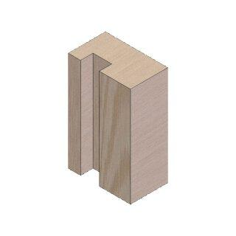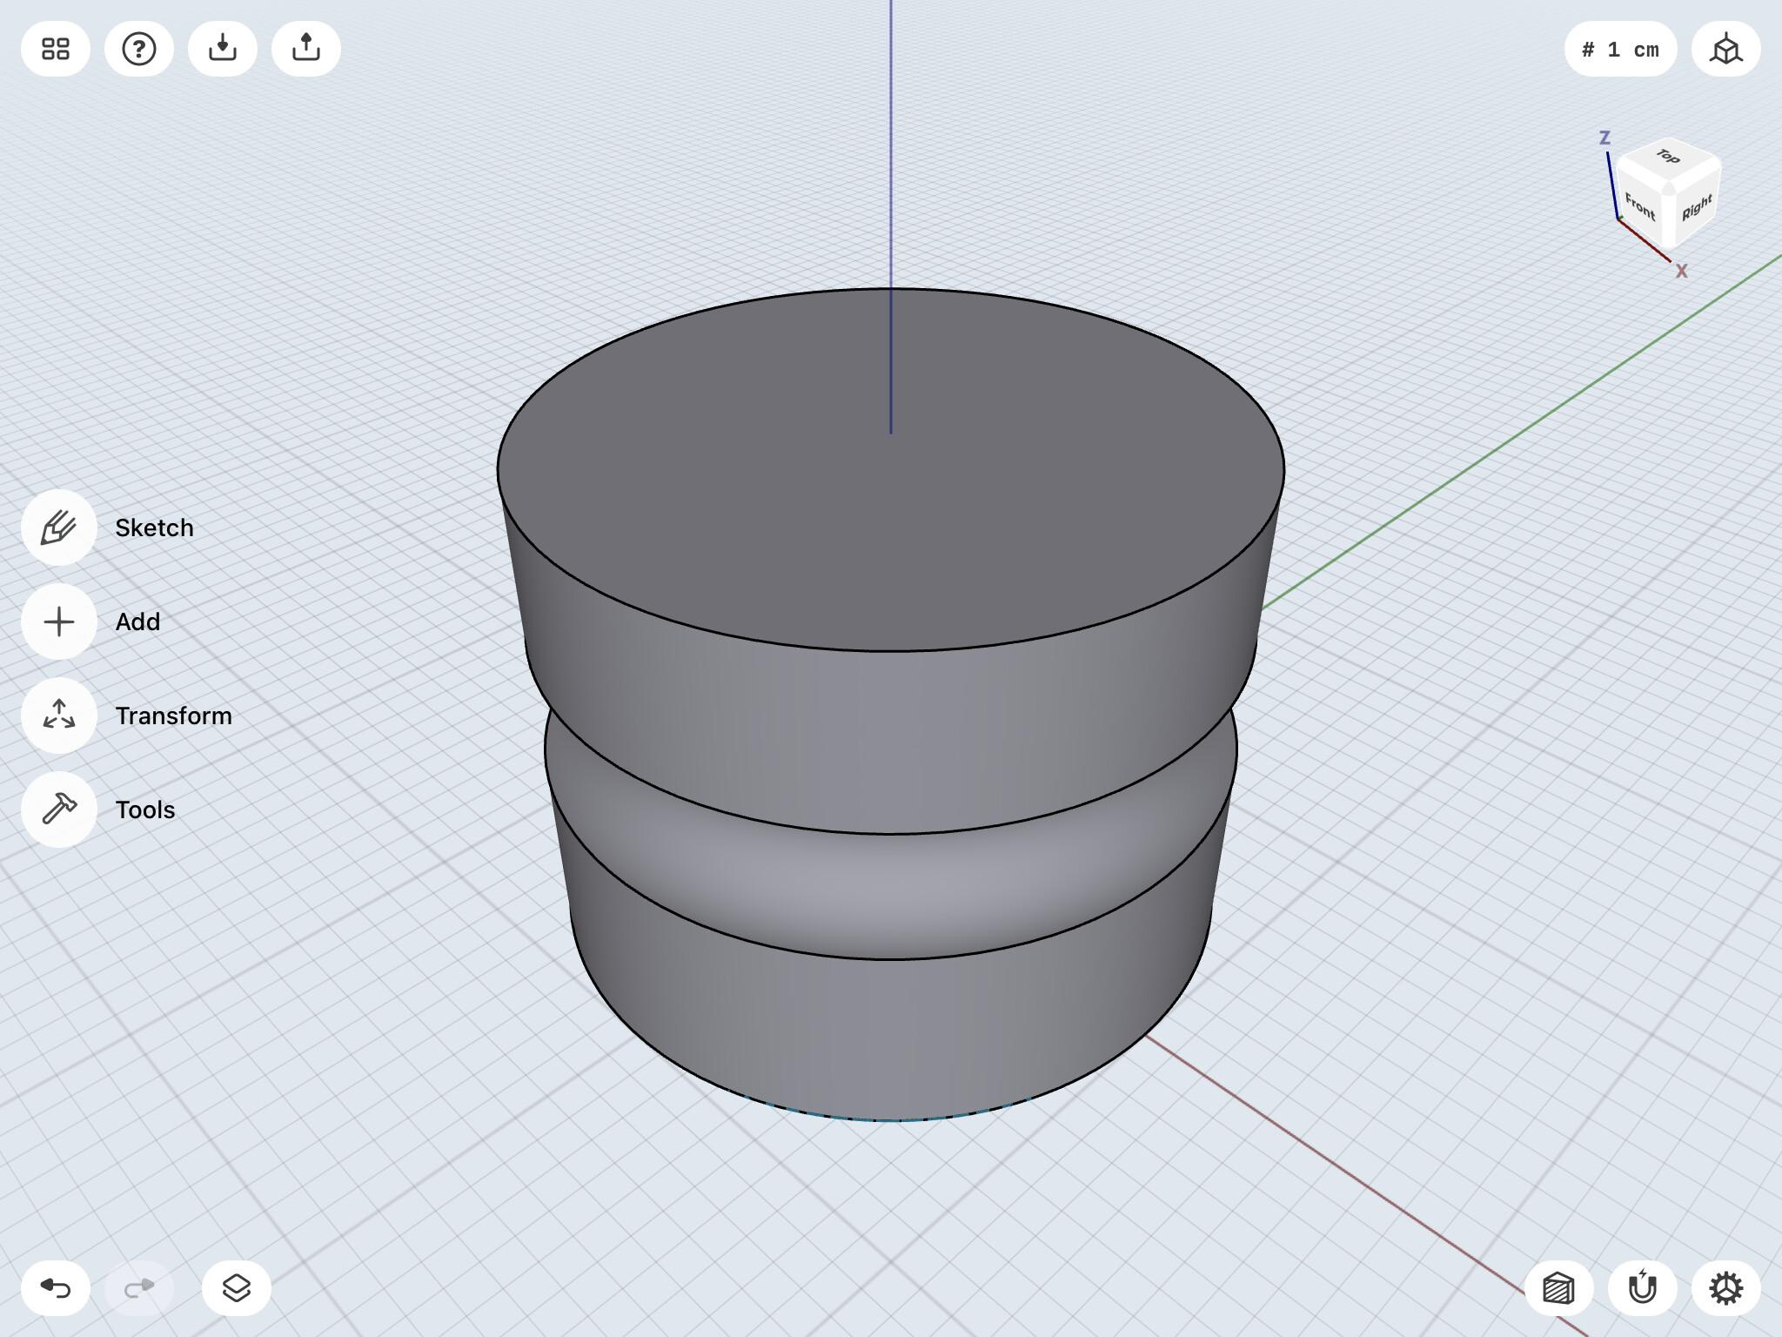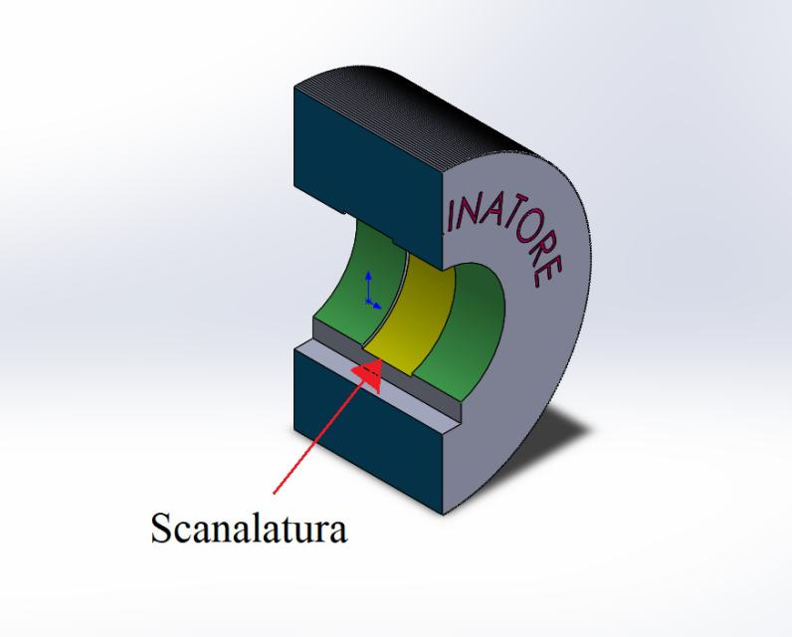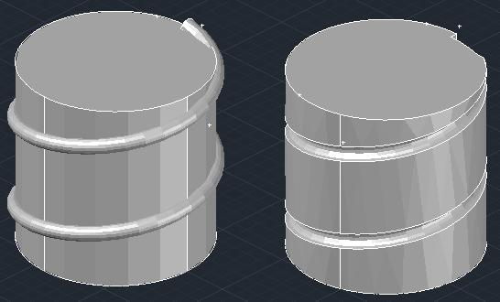

Mathematical Properties and Formulas

Remaining Volume
# Source: AI Source: Provided by: [Data Path: Persons Table -> ID Column: 1, Name_En Column: Motasem Essam] -> From: [ChatGPT] on [7/25/2026]
The remaining volume is calculated by subtracting the groove volume from the original solid volume.
$$\boxed{V_{r}=V_{o}-V_{g}}$$
Where:
- $V_{r}$ = Remaining volume.
- $V_{o}$ = Original solid volume.
- $V_{g}$ = Removed groove volume.
For multiple non-overlapping grooves:
$$\boxed{V_{r}=V_{o}-\sum_{i=1}^{n}{V_{g_{i}}}}$$
Overlapping grooves require correction for their shared removed regions.

Common Groove Volume Formulas
# Source: AI Source: Provided by: [Data Path: Persons Table -> ID Column: 1, Name_En Column: Motasem Essam] -> From: [ChatGPT] on [7/25/2026]
For a groove with a constant cross-sectional area:
$$\boxed{V_{g}=A_{cL}}$$
Where:
- $A_{c}$ = Cross-sectional area of the groove.
- $L$ = Groove length.
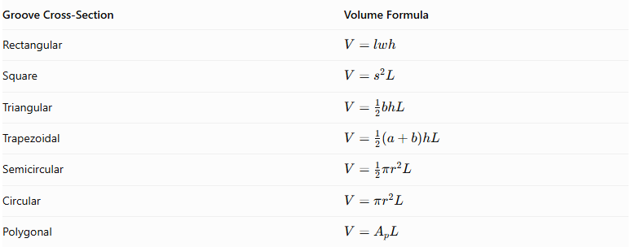
Groove Cross-Section | Volume Formula
Rectangular | $$V=lwh$$
Square | $$V=s^{2}L$$
Triangular | $$V=\frac{1}{2}bhL$$
Trapezoidal | $$V=\frac{1}{2}(a+b)hL$$
Semicircular | $$V=\frac{1}{2}πr^{2}L$$
Circular | $$V=πr^{2}L$$
Polygonal | $$V=A_{pL}$$
For a groove with a changing cross-section:
$$V_{g}=\int_{0}^{L}{A}(x),dx$$
Where $A(x)$ is the cross-sectional area at position $x$.

Surface Area
# Source: AI Source: Provided by: [Data Path: Persons Table -> ID Column: 1, Name_En Column: Motasem Essam] -> From: [ChatGPT] on [7/25/2026]
The remaining surface area is calculated by removing the original surface area covered by the groove opening and adding the newly exposed internal groove surfaces.
$$\boxed{{SA}_{r}={SA}_{o}-A_{opening}+A_{new}}$$
For a rectangular groove with:
- Width $w$
- Depth $d$
- Length $L$
- Vertical walls
- Flat bottom
The removed opening area is:
$$A_{opening}=wL$$
The new bottom area is:
$$A_{bottom}=wL$$
The two internal side-wall areas are:
$$A_{walls}=2dL$$
Therefore:
$${SA}_{r}={SA}_{o}-wL+wL+2dL$$
$$\boxed{{SA}_{r}={SA}_{o}+2dL}$$
This formula assumes a straight rectangular groove with vertical walls, a flat bottom, and an opening entirely within one flat face.
For a semicircular groove with radius $r$ and length $L$, the curved internal surface area is:
$$A_{curved}=πrL$$
If the opening and the removed surface area are both the same rectangular strip of width $2r$, then:
$${SA}_{r}={SA}_{o}-2rL+πrL$$
$$\boxed{{SA}_{r}={SA}_{o}+(π-2)rL}$$
This assumes a semicircular cross-section and a straight groove fully contained within a flat surface.

Worked Examples

Example 1: Rectangular Groove Subtraction
# Source: AI Source: Provided by: [Data Path: Persons Table -> ID Column: 1, Name_En Column: Motasem Essam] -> From: [ChatGPT] on [7/25/2026]
A rectangular prism has dimensions:
- Length = 12 cm
- Width = 8 cm
- Height = 6 cm
A rectangular groove is cut along the full length of its top surface with:
- Groove width = 2 cm
- Groove depth = 2 cm
- Groove length = 12 cm
Find the remaining volume and surface area.
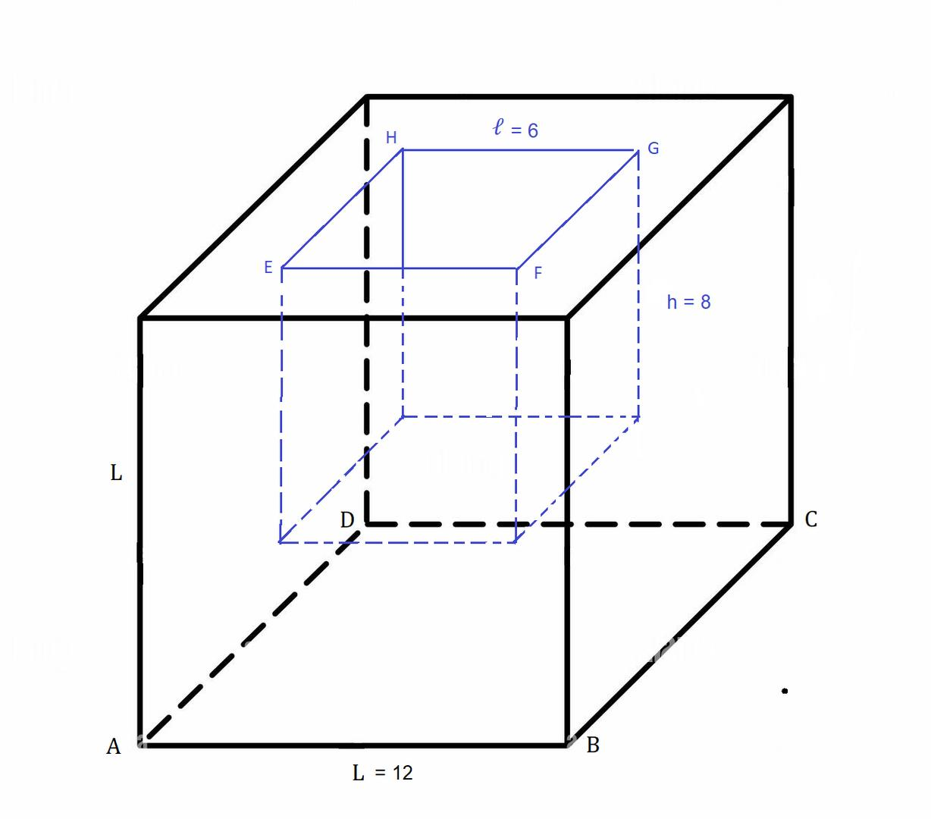
Step 1: Calculate the original volume.
$$V_{o}=12×8×6$$
$$V_{o}=576{ cm}^{3}$$
Step 2: Calculate the removed groove volume.
$$V_{g}=12×2×2$$
$$V_{g}=48{ cm}^{3}$$
Step 3: Calculate the remaining volume.
$$V_{r}=576-48$$
$$\boxed{V_{r}=528{ cm}^{3}}$$
Step 4: Calculate the original surface area.
$${SA}_{o}=2(lw+lh+wh)$$
$$=2(96+72+48)$$
$${SA}_{o}=432{ cm}^{2}$$
Step 5: Calculate the remaining surface area.
The top opening area removed is:
$$A_{opening}=12×2=24$$
The new bottom area is:
$$A_{bottom}=24$$
The two internal walls have a combined area:
$$A_{walls}=2(12×2)=48$$
Therefore:
$${SA}_{r}=432-24+24+48$$
$$\boxed{{SA}_{r}=480{ cm}^{2}}$$
Final Answer:
- Remaining Volume = 528 cm³
- Remaining Surface Area = 480 cm²

Example 2: Semicircular Groove Subtraction
# Source: AI Source: Provided by: [Data Path: Persons Table -> ID Column: 1, Name_En Column: Motasem Essam] -> From: [ChatGPT] on [7/25/2026]
A rectangular prism has dimensions:
- Length = 10 cm
- Width = 8 cm
- Height = 6 cm
A semicircular groove is cut along the full length of its top surface with:
- Radius = 2 cm
- Groove length = 10 cm
Find the remaining volume and surface area.
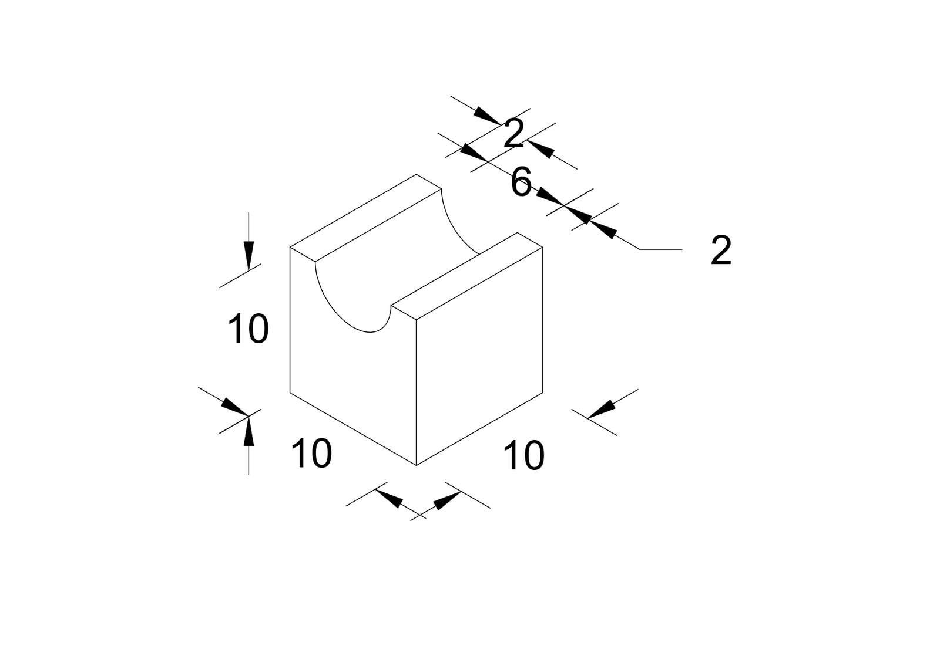
Step 1: Calculate the original volume.
$$V_{o}=10×8×6$$
$$V_{o}=480{ cm}^{3}$$
Step 2: Calculate the removed groove volume.
The groove has a semicircular cross-section:
$$V_{g}=\frac{1}{2}πr^{2}L$$
$$=\frac{1}{2}π(2)^{2}(10)$$
$$V_{g}=20π{ cm}^{3}$$
Step 3: Calculate the remaining volume.
$$V_{r}=480-20π$$
$$\boxed{V_{r}≈417.17{ cm}^{3}}$$
Step 4: Calculate the original surface area.
$${SA}_{o}=2(10×8+10×6+8×6)$$
$${SA}_{o}=376{ cm}^{2}$$
Step 5: Calculate the remaining surface area.
The rectangular opening removed from the top surface has width equal to the semicircle's diameter:
$$A_{opening}=10×4=40$$
The curved internal surface area is:
$$A_{curved}=πrL$$
$$=π(2)(10)=20π$$
The two semicircular end regions are removed from the original end faces, but their areas are replaced by the new end boundaries of the same shape. Their net contribution is zero.
Therefore:
$${SA}_{r}=376-40+20π$$
$$\boxed{{SA}_{r}≈398.83{ cm}^{2}}$$
Final Answer:
- Remaining Volume = 417.17 cm³
- Remaining Surface Area = 398.83 cm²

Important Characteristics
# Source: AI Source: Provided by: [Data Path: Persons Table -> ID Column: 1, Name_En Column: Motasem Essam] -> From: [ChatGPT] on [7/25/2026]
- Material is removed in an elongated path along a solid's surface.
- The resulting feature is a recessed channel or track.
- A groove generally has a definable length, width, and depth.
- Its cross-section may be rectangular, square, triangular, trapezoidal, semicircular, or irregular.
- Its path may be straight, curved, circular, helical, or wavy.
- It may extend along an entire surface or only a portion of it.
- Multiple grooves can be parallel, intersecting, concentric, or distributed.
- The remaining volume is smaller than the original volume.
- The surface area depends on the opening area and newly exposed internal surfaces.
- A groove can be formed on flat, curved, external, or internal surfaces.

Comparison with Other Subtraction Methods
# Source: AI Source: Provided by: [Data Path: Persons Table -> ID Column: 1, Name_En Column: Motasem Essam] -> From: [ChatGPT] on [7/25/2026]
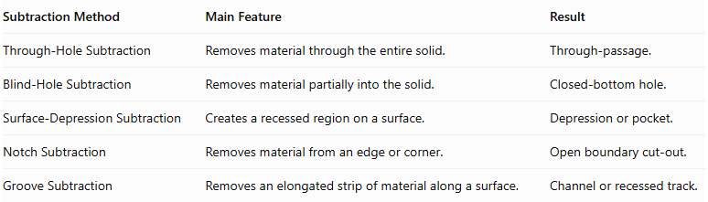
Subtraction Method | Main Feature | Result
Through-Hole Subtraction | Removes material through the entire solid. | Through-passage.
Blind-Hole Subtraction | Removes material partially into the solid. | Closed-bottom hole.
Surface-Depression Subtraction | Creates a recessed region on a surface. | Depression or pocket.
Notch Subtraction | Removes material from an edge or corner. | Open boundary cut-out.
Groove Subtraction | Removes an elongated strip of material along a surface. | Channel or recessed track.
Important distinction: A groove is primarily characterized by its elongated shape and path. A surface depression is characterized by a recessed region, which may be broad or compact. A notch is characterized by its opening through an edge or boundary.

Applications
# Source: AI Source: Provided by: [Data Path: Persons Table -> ID Column: 1, Name_En Column: Motasem Essam] -> From: [ChatGPT] on [7/25/2026]
Groove subtraction is commonly used in:
- Mechanical engineering: keyways, guide channels, and fitting grooves.
- Manufacturing: machined channels and surface tracks.
- Construction: drainage grooves and structural channels.
- Architecture: decorative grooves and linear recesses.
- Automotive engineering: sealing grooves and lubrication channels.
- Pipe design: internal flow channels and circumferential grooves.
- Product design: sliding tracks and component guides.
- Furniture design: panel grooves and joining channels.
- Industrial design: ventilation channels and alignment tracks.

Key Points
# Source: AI Source: Provided by: [Data Path: Persons Table -> ID Column: 1, Name_En Column: Motasem Essam] -> From: [ChatGPT] on [7/25/2026]
- Groove subtraction removes an elongated region of material from a solid's surface.
- It creates a recessed channel or track.
- Grooves can be classified by cross-section, direction, path, depth, location, and arrangement.
- Groove volume is calculated using cross-sectional area multiplied by groove length when the cross-section is constant.
- Remaining surface area must account for the removed opening and the newly exposed internal surfaces.
- Grooves differ from notches because they are generally characterized by an elongated surface path rather than a boundary cut-out.

Conclusion
# Source: AI Source: Provided by: [Data Path: Persons Table -> ID Column: 1, Name_En Column: Motasem Essam] -> From: [ChatGPT] on [7/25/2026]
Groove Subtraction is an important classification of composite solids formed by subtraction. It involves removing an elongated portion of material from a solid's surface to create a channel, track, or recessed path.
Grooves can have different cross-sectional shapes, directions, depths, and arrangements. Their geometric properties allow the remaining volume and external surface area to be calculated using the dimensions of the removed region and the newly exposed surfaces.

